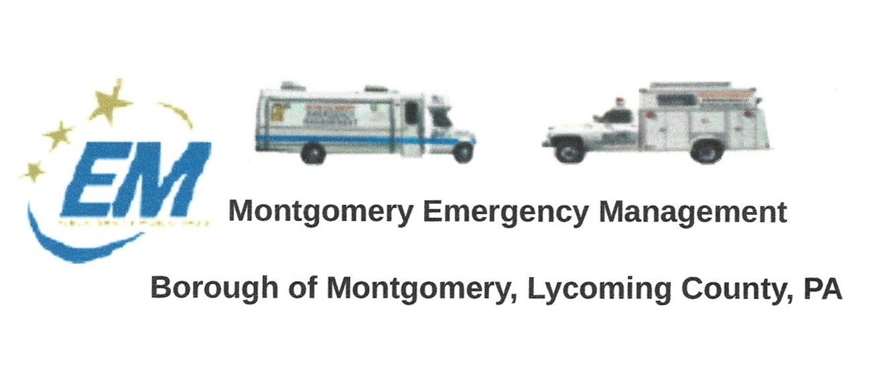
The regular monthly meeting of the Montgomery Borough Emergency Agency will be:
Greg Gruver, EMA Coordinator. 77 East Houston Avenue, Montgomery, PA 17752
Telephone: 570-547-1212. Cell: 570-419-4866. Email: montema631@gmail.com
Fae Herb, Administrative Assistant. 102 Broad Street, Montgomery, PA 17752
Cell: 570-506-9892. Email: faeherb@aol.com
Meeting Room and Equipment Building: 40 Thomas Avenue
Borough EOC: 570-547-1671 Fire Hall EOC: 570-547-1380
INTERNET WEBSITE: WWW.montgomeryboroughema.org
THURSDAY, MARCH 11, 2021 7 p.m.
NOTES FROM OUR EMA DEPUTY COORDINATOR – DENNIS GRUVER
The month of March roared in like a Lion, but the temperatures are getting warmer, and the snow is melting at a very safe pace. We like to thank Dale, Greg, and Caleb for keeping the EMA building staging area clear of snow and ready for the next event.
As the snow melts, the runoff and possibility of flash flooding can occur. We have a long history knowing that large material that blocks the Railroad underpass can (and will) create a great deal of water to back up behind the Borough Building and along Brook Street. THIS HAPPENED IN 1999. Why did this happen? Borough Officials did not enforce the codes and allowed abandon vehicles to remain in the flood way. (Special Note: Dennis spoke of this incident in his interview with Larry Stout for the Webb Weekly). At the present time there is one vehicle behind the OIP building that can not move. The vehicle owner has been asked several times to correct the issue and yet it remains. THIS IS A FLOOD PLAIN AND DEBRIS THAT GATHERS THERE CAN EFFECT THE ENTIRE AREA. In the event of flash flooding, a plan of contacting the apartment landlords to inform their tenants to move their vehicles to higher ground needs to be in place. The Borough Safety Committee should review and follow up on this action.
The EMA has four minitor pagers that can be activated from all the 2180 portable radios and base stations. This allows quicker notification of key members in a time of emergency. Those members are Dennis (6-1), Greg (6-31), Dale (6-15) and Ed Alexander (6-5). PLEASE BRING YOUR PORTABLE RADIO TO THE MARCH MEETING SO WE CAN TEST THIS FEATURE. Ryan Gross will add ID to all the portable units at the APRIL meeting .
The Annual Lion’s Club Easter Egg Hunt will be Saturday, April 3, 2021. Volunteers will be needed to help with the PA System. Saturday, April 17, 2021 the Lions Riverside 5K Walk For Vision will take place and volunteers will be needed for this event also.
REFRESHEMENTS FOR MARCH WILL BE PROVIDED BY ED FERGUSON
RADIO AND PAGER CHECK EVERY TUESDAY NIGHT AT 6 P.M.
Dennis Gruver – Deputy Coordinator
Fae Herb – Administrative Assistant

